This is the Title of our practice document
Titles should be used on a title page as the overall name of the document. This would usually precede a table of contents. If you have a document longer than 2 or 3 pages, you should have a table of contents. https://www.mass.gov
Hola, como estas?

This is a Heading 1
A Heading 1 acts as the title for your main body of content. There would typically be only one Heading 1 in your document. Headings should follow the order of an outline, such as:
- Heading 1
  - Heading 2
  - Heading 2
    - Heading 3
    - Heading 3
  - Heading 2
    - Heading 3
      - Heading 4
  - Heading 2
    - Heading 3
    - Heading 3
Not only does this allow you to have an accurate table of contents, but it also helps users of assistive technology skim your document and understand its structure.
Some of the following "headings" in the document are fake and are not actual headings. Try to figure out which headings are real, and which aren't using the Accessibility Checker!
Is this a Heading?
That could have been a heading, but it isn't. Select it with your cursor and open the Styles Pane. Notice that the "Normal" body text style is highlighted. The font is just larger and bold.

What about this one?
This is a Heading! It's a Heading 3! But we haven't had a Heading 2 yet! Remember headings should always be in order, and not skip levels.

The Styles Pane
The Styles Pane contains multiple different formats for headings, among other styles. The look of a heading can be modified. It's not important that you use the default visual style of a heading, just that it has been formatted as a heading. You can use the Styles Pane to modify the look of any of your headings.
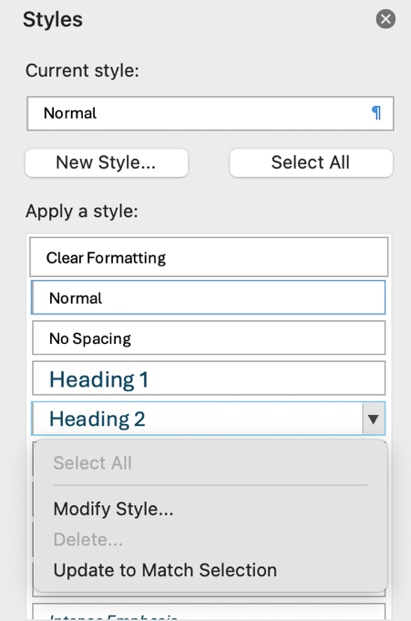

Images
Here are three images. One is correct and two are incorrect. Use the Accessibility Checker to find out which have issues.
(Review Tab > Check Accessibility)
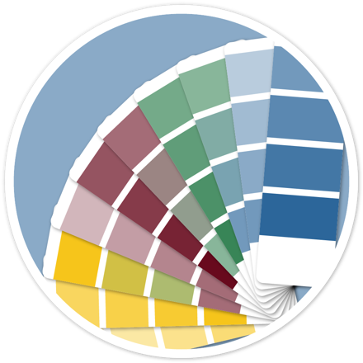 | 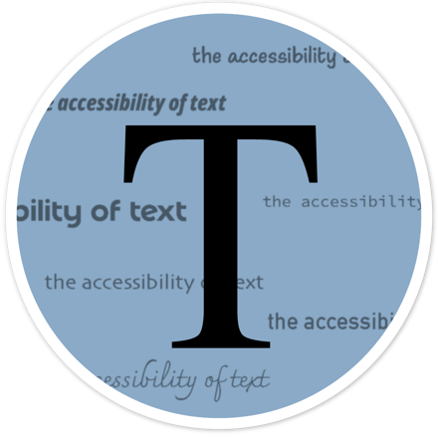 | 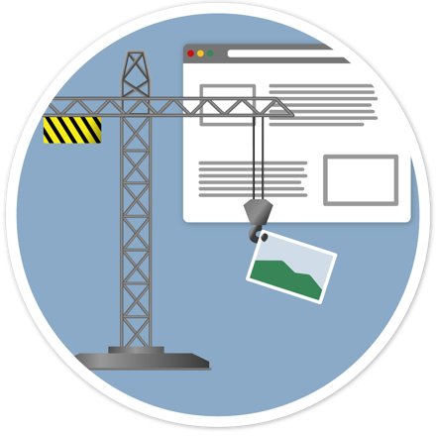

Floating images
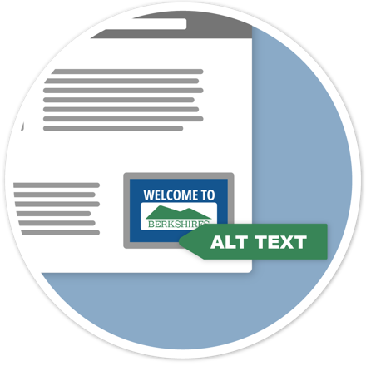
The following image has an additional problem because it is "floating." An image that is not "in line with text" will not be found in the correct spot in the document by a screen reader. In fact, all floating images will be listed before your content, if at all, so they will be completely out of context. You can tell it's a floating image by the fact that when you select it, it can be moved anywhere, and there will be an anchor icon to the left side of the page. The Accessibility Checker will point this out and tell you how to fix it!

Table: Student Population
Insert a table with three rows and four columns.

